

**Safeguarding and Child Protection Policy**

**September 2016**

*This policy was last reviewed and ratified by the Governing Body: September 2016*



**Safeguarding and Child Protection Policy**

**Contents**

|  |
| --- |
| Rational  Definitions  Aims |
| Prevention |
| Procedures |
| Supporting Vulnerable Pupils and those at Risk |
| Bullying/Cyber bullying |
| Pupils with Mental Health Difficulties |
| Physical Intervention |
| Children with Statements of Special Education Needs (SEN) |
| Safe use of the Internet and Digital Technology |
| Contact with Pupils |
| Safer Recruitment |
| Allegations against Staff |
| School Site Security |
| Confidentiality |
| Monitoring and Reviewing |
| Table of Appendices |

**Rationale**

Under the Safeguarding Children Agenda, our school recognises that a Safeguarding Policy requires a broader view than that of the traditional child protection policy. The *Safeguarding Children in Education* model and Child Protection Policy has been incorporated into this Policy. Therefore, a number of elements that would previously not have been within a child protection policy have been incorporated. However, absolute focus is maintained that the aim of this document is the protection and welfare of children and young people.

**“The interest of the child is paramount in all** **considerations of welfare and safeguarding.**

**Safeguarding children is everyone's responsibility”**

Safeguarding Children: Working Together Under the Children Act 2004

**Definitions**

At the outset, it is critical that definitions of the terms used within this policy are clarified. (*Appendix A)* includes definitions and concepts taken from the Safeguarding Children: Working Together Under the Children Act 2004 and are included here for ease of reference and to ensure that common terminology is used to assist in work undertaken between partners.

The underpinning policy principles ensure that the health, safety and welfare of all our children and young people in Ysgol Y Deri are of paramount importance to all the adults who work in our school. Our children and young people have the right to protection, regardless of age, gender, race, culture, religion or disability. They have a right to be safe in our school. All staff have an equal responsibility to act upon any suspicion or disclosure that may suggest a child is at risk of harm.

Legislation forms the basis for this Policy and the Vale of Glamorgan Safeguarding & Child Protection Policies. The following, therefore, is consistent with the Vale of Glamorgan Policy:

**Aims**

* to provide a safe environment for children/young people in which to learn;
* to establish what actions the school can take to ensure that children/young people remain safe at home as well as at school;
* to raise the awareness of all staff to these issues, and to define their roles and responsibilities in reporting possible cases of abuse;
* to identify children/young people who are suffering, or likely to suffer, significant harm;
* to ensure effective communication between all staff on child protection issues;
* to set down the correct procedures for those who encounter any issue of child protection.

‘Safeguarding’, is not just about protecting children/young people from deliberate harm. It encompasses issues for schools including:

* pupil health and safety
* bullying/cyberbullying
* racist abuse
* harassment and discrimination
* radicalisation and extremism
* use of physical intervention / safe handling
* meeting the needs of pupils with medical conditions
* providing first aid
* drug and substance misuse
* educational visits
* sex and relationship education
* internet safety
* issues which may be specific to a local area or population e.g. gang activity
* school security
* the welfare of learners on extended vocational placements

Ysgol Y Deri has separate policies which aim to address many of the above areas. The school has a Vulnerable Adults Policy, (Safeguarding for our students who are aged 18 years plus), Health & Safety Policy that addresses many of the areas including security, pupil welfare and educational visits; we also have a separate Anti Bullying Policy, Racial Equality Policy, E-Safety Policy, Physical Intervention Policy, and Time out Policy, Educational Visits Policy, Sex and Relationship Policy, Personal and Social Policy, School Security Policy, Vocational Placement Policy, Whistleblowing Policy, Strategic Equality Plan.

Ysgol Y Deri fully recognises the contribution it makes to Safeguarding Children and Young people.

There are three main elements to our policy: -

1. Prevention through the teaching and pastoral support offered to children and young people;
2. Procedures that clearly outline the expectations of all parties within a Safeguarding agenda for identifying and reporting cases, or suspected cases, of abuse, concern and or vulnerability. Because of our day to day contact with children and young people school staff are well placed to observe the outward signs of abuse
3. Support to children and young people who may have been abused, give a cause for concern or are vulnerable.

This policy applies to all staff and volunteers working within the school. Additionally, this policy applies to all occasional workers, volunteers, contractors and governors. Learning support assistants, mid-day supervisors, cleaners, caretakers, secretaries as well as teachers may be the first point of disclosure for a child or young person. All adults on school site must be aware of the school’s Safeguarding and Child Protection Policy.

Within this school the Head Teacher retains overall responsibility for Safeguarding. The Named Senior Officer for Safeguarding in the Learning and Skills Directorate is:

Dorian Davies (Tel: 01446 709867 or 07816896572).

Key safeguarding personnel within the school are:

* The Designated Senior Person for Child Protection (DSP) is Christopher Britten
* The Deputy Designated Senior Persons for Child Protection (DDSPs) are Claire Gould, Josie Mc Allister, Kerrie Pritchard and Sian Davey.
* The Designated Senior Governor for Child Protection (DSG) is Tim Exell

(*Appendix B* outlines the detailed roles and responsibilities of each post)

**Prevention**

We recognise that high self-esteem, confidence, supportive friends and good lines of communication with a trusted adult help to safeguard children and young people.

The school will therefore:-

* establish and maintain an ethos where children and young people feel secure and are encouraged to talk, and are listened to;
* ensure children and young people know that there are adults within the school whom they can approach if they are worried or in difficulty;
* include in the curriculum, activities and opportunities for Personal Social Education (PSE) which equip children and young people with the skills they need to stay safe from abuse or exploitation, both in their own communities and the cyber community, and to know to whom to turn for help; and
* include within the curriculum, material that will help children and young people develop realistic attitudes to the responsibilities of adult life, particularly with regard to childcare and parenting skills.
* Our non verbal pupils have tools to help them communicate where ever possible.
* It is the responsibility of the staff to look closely for changes in behaviour and for signs of possible abuse or neglect. This is particularly important when working with out more vulnerable pupils who are non verbal.

All staff demonstrate a total commitment to Safeguarding and Child Protection. They raise children’s and young people’s awareness of themselves through Personal and Social Education (PSE) and develop a trusting climate so that they feel able to talk and share their thoughts and feelings. The school also helps to develop appropriate attitudes in our children and young people and make them aware of the impact of their decisions on others. Staff also teach them how to recognise different risks in different situations, and how to behave in response to them.

In our school we respect our children and young people. The atmosphere within our school is one that encourages all children and young people to do their best. Opportunities are provided that enable them to take and make decisions for themselves.

We recognise that abuse and neglect can result in underachievement. We strive to ensure that all our children and young people make optimum educational progress.

**Procedures**

Ysgol Y Deri school follows the All Wales Child Protection Procedures that have been endorsed by the Local Safeguarding Board (LSCB). All local protocols in relation to safeguarding that have been endorsed by Cardiff and the Vale of Glamorgan Local Safeguarding Children Board.

Ysgol Y Deri:-

* has a designated senior person for Child Protection (DSP) Christopher Britten, who has undertaken the appropriate training and deputy designated senior persons: Claire Gould, Josie Mc Allister, Kerrie Pritchard, and Sian Davey, who will substitute in the designated person’s absence. This substitute is a senior member of staff and shadows the CP Designate. In the absence of all DSPs from school, the Assistant Heads, Emma Carver will substitute and consult with the Safeguarding Officer, Dorian Davies if required.
* ensures appropriate arrangements are in place for the support and training of the DSP and the DDSPs. This includes attending training course Working Together to Safeguarding Children, including training at Level 1 and Level 2 and train the trainer course, every two years. DSP or DDSP also attend DSP forums provided by the LEA, at least termly. At least one other safeguarding training course is attended annually.
* ensures that in the event of the DSP and Deputy DSPs not being available to deal with an emergency involving Child Protection issues, the member of staff with the concern should follow procedures laid out in this policy.
* has identified a specific governor who is a designated Child Protection link and who will oversee the school’s safeguarding policy and practice;
* ensures that every member of staff and every governor knows:-
* the name of the designated persons and their roles
* that they have an individual responsibility for referring child protection concerns using the appropriate channels and within the timescales agreed with the LSCB.
* how to take forward those concerns where the designated senior person is unavailable.
* ensure that members of staff are aware of the need to be alert to signs of abuse and know how to respond to a pupil who may disclose abuse
* ensure that parents have an understanding of the responsibility placed on the school and staff for child protection by setting out its obligations in the school brochure or website;
* provides training for all staff so that they know:
* their personal responsibility
* the agreed local procedures
* the need to be vigilant in identifying cases of abuse and vulnerability
* how to support a child or young person who discloses abuse (*Appendix* M)

Training for Safeguarding and Child Protection takes place annually for existing staff and within the first term of starting employment for new staff.

* will notify the appropriate social services team if:
* a child or young person who is on the Child Protection Register (CPR) is excluded either for a fixed term or permanently;
* if there is an unexplained absence of a child/young person who is on the CPR of more than two days duration from school (or one day following a weekend)
  + works to develop effective links with relevant agencies and co-operated as required with their enquiries regarding child protection matters including attendance at initial and review child protection conferences, core groups and submission of written reports to the conference. (*Appendix G*) and MARAC reports *(Appendix H);*
* ensures that members of staff are aware of the definitions of abuse and neglect (*Appendix* C), and the need to be alert to signs of abuse.
* Ensures that members of staff are aware of the signs of vulnerabilities for terrorism and extremism.
* keeps written records of concerns about children (noting the date, event and action taken), even where there is no need to refer the matter to social services immediately.
* ensures all records are kept secure and in locked locations
* holds fortnightly Multi Agency Sharing Information Meetings (MAISM) to discuss completed logs, with school leadership team (Only where parental consent for information sharing has been given.)
* adheres to the procedures set out in the Welsh Government circular 002/2013: “Disciplinary and Dismissal Procedures for School Staff”.
* ensures that recruitment and selection procedures are made in accordance with Welsh Government guidance “Keeping Learners Safe”.

What to do if a child tells you that they or another child or young person is being abused:

* Show the child that you have heard what they are saying, and that you take their allegations seriously;
* Encourage the child to talk, but do not prompt or ask leading questions;
* Don’t interrupt when the child is recalling significant events. Don’t make the child repeat their account;
* Explain what actions you must take, in a way that is appropriate to the age and understanding of the child;
* Do not promise to keep what you have been told secret or confidential, as you have a responsibility to disclose information to those who need to know. Reporting concerns is not a betrayal of trust;
* Write down as soon as you can and no later than 24 hours what you have been told, using the exact words if possible. Keep rough notes;
* Report your concerns to your line manager or (if appropriate) the member of staff in your organisation with designated responsibility for child protection;
* Do not confront the alleged abuser;
* Do not worry that you may be mistaken. You will always be taken seriously by CYPS. It is better to have discussed it with somebody with the experience and responsibility to make an assessment;
* Make a note of the date, time, place and people who were present at the discussion.’

*Records of Concern/Significant Event/Disclosure*

A Safeguarding Log *(Appendix D)* should be completed whenever a member of staff has concerns, is alerted to a significant event or a disclosure or when a child presents with a marked change of behaviour, or has vulnerabilities that may suggest a risk of radicalisation or extremism. The Safeguarding Log should be completed noting the date of the event/concern and action taken. This record of concern should be signed by both the referrer and the DSP or DDSP and a copy kept by the DSP, even when there is no need to refer the matter to CYPS immediately. Safeguarding Logs can be obtained from admin staff Jane Brown or Ginnette Milford. A record of distribution is recorded and notification provided to DSP and DDSPs. If the concern involves bruises or marks, then a body chart (*Appendix E*) must also be completed and handed in with the Safeguarding Log.

If there is a concern of Female Genital Mutilation, there is a mandatory reporting duty on that staff member to call the police.

All staff should be aware of the following paragraph from AWCPP 2008:

If any person has knowledge, concerns or suspicions that a child is suffering, has suffered or is likely to be at risk of harm, it is their responsibility to ensure that the concerns are referred to CYPS or the police, who have statutory duties and powers to make enquiries and intervene when necessary. AWCPP 2008 page 73.

NB If a referrer disagrees with a decision made by the DSP, who decides not to pass on concerns, it is the referrer’s responsibility to make that referral.

*Chronology Log*

The Chronology Log *(Appendix F)* is to be used to build up a picture, if concerns remain. This is in the front of each individual pupil’s safeguarding folder.

*Storing records*

All records must be kept secure and in locked locations and children’s and young people’s files must be kept individually and separately in line with the Pupil Information Record System as supplied by the Directorate of Learning and Skills*.* (Suggested Safeguarding File Composition *Appendix L*). Concerns will be shared with relevant professionals involved with the child, but records will not be available without the authority of the Designated Senior Person (DSP) Headteacher. Safeguarding Pupil Information Records *(Appendix J)* are kept in individual files.

*Transfer of Files*

All Safeguarding information must be transferred to a new school immediately when a child and young person on the Child Protection Register, or who has a diagnosed mental health difficulty, or who is known to CYPS, leaves. CYPS must be informed of the child’s or young person’s transfer. The DSP will ensure that the receiving school is fully aware of any Safeguarding concerns and that the file is copied and transferred separately in a secure, appropriate manner. Key documents in the file must be copied and kept in school. (Child Protection records should be kept until a child reaches the age of 25) If the school is unable to ascertain what school/educational setting the child/young person is transferring to, the school must inform the Named Senior Officer for Safeguarding in the learning and Skills Directorate – Dorian Davies;

*Procedures for school based staff*

All staff and volunteers working with children and young people are well placed to observe outwards signs of abuse, changes in behaviour or failure to develop. They therefore have a duty to safeguard and promote the wellbeing of pupils and comply with the All Wales Child Protection Procedures.

When a member of staff, teaching or non – teaching, is alerted to signs of abuse or neglect s/he should:

* Discuss the issue with the school’s DSP or in his/her absence the DDSP.
* Complete the Safeguarding Log Record of Concern/Significant Event/Disclosure (noting the date, event and action taken), even where there is no need to refer the matter to CYPS immediately and pass it to the DSP or DDSP.
* If the decision is taken that the incident needs to be referred, the DSP/DDSP should make a telephone referral to CYPS by telephoning the Duty Officer on 01446 725 202, or out of hours on 02920 788570. Some pupils live in other Local Authorities. Where this is the case the local duty team should be telephoned (*Appendix P).* This must be followed within two working days by completing the Multi-Agency Referral Form (MARF) or Prevention of Vulnerable Adults (POVA) either in writing or via e-mail to: [dutymarfs@valeofglamorgan.gov.uk](mailto:dutymarfs@valeofglamorgan.gov.uk). If the “Child in Need” referral box is ticked, it must be accompanied with parental consent. No parental consent is needed for the “CP” referral box. The “Information Only” referral box will be logged by CYPS and only acted upon if it is considered a CP matter.

*The Duty Officer*

*Vale of Glamorgan Council*

*Dock Office*

*Barry*

*CF63 4RT*

* The DSP/DDSP should ensure that parents are informed and made aware of the referral, other than in circumstances when doing so would put the child at further risk of harm.
* Safeguarding Logs should always be added to the Chronology Log to enable the school to build up a picture of what might be going on for the child or young person.

(Advice may be sought prior to referral from the above asking for the duty desk, or the Safeguarding Officer, Dorian Davies– Safeguarding Officer 01446 709 867)

Following the referral, the school must:

* Be kept informed of the strategy discussions and attend strategy meetings / case conferences / core group meetings as required
* Record the date, event, action taken and result of suspected child abuse and keep records confidential, separate and secure;
* Contribute to the coordinated approach to Child Protection by developing effective liaison with other agencies and support.
* Provide written reports, using appropriate Local Authority Multi Agency Referral Form (MARF) which can be located on the school server, and/or report for conference (*Appendix G)*

*Procedures for the Learning and Skills Directorate Staff*

Staff who visit schools (both centrally based staff such as the SIIS, Challenge Advisers and those providing commissioned services) may also receive pupil disclosures or gain evidence of possible abuse including neglect.

They should share the information with the school’s DSP, or the DDSP. If following discussion, the decision is taken that the incident needs to be referred, the DSP should make the referral to CYPS, by telephoning the Duty Officer. This must be followed up within two working days by completing the Multi-Agency Referral Form (MARF) either in writing or via email dutymarfs@valeofglamorgan.gov.uk. Following this they should inform their line manager, or in her/his absence, Dorian Davies 01446 709867.

This should be done without delay (same day) and a copy of the MARF provided on completion. If no child protection referral is made, a full written record must be provided to the school using the Record of Concern/ Disclosure/Significant Event Form, *(Appendix D***),** with an e-copy to Dorian Davies

Similarly, adults employed by the Council to work with children or young people outside the school setting e.g. members of the Youth Service, should inform their line manager, or in her/his absence the Local Authority Safeguarding Officer, Dorian Davies 01446 709867 or in his absence Ruth Ferrier, 01446 709 811

As the adult who first raised the concern, it is the visiting member’s responsibility to ensure that the school has acted upon the concerns raised. The responsibility for taking procedures further lies with the visiting member if they are not satisfied with the school’s response. If this is the case, concerns should be shared with Dorian Davies who will liaise with the school.

It is not the responsibility of staff in school, visiting schools or working with children and young people, or in Youth settings, to investigate suspected child abuse, only to report any disclosure or apparent evidence.

**Supporting vulnerable pupils and those who are at risk**

Ysgol Y Deri recognises that children and young people who are at risk, suffer abuse, neglect or witness violence may be deeply affected by this.

This school may be the only stable, secure and predictable element in the lives of children/young people at risk. Nevertheless, when at school their behaviour may be challenging and defiant or they may be withdrawn.

The school will endeavour to support the child or young person through:-

* the content of the curriculum to encourage self esteem and self motivation;
* the school ethos which:
* promotes a positive, supportive and secure environment; and
* gives children/young people a sense of being valued
* the school’s behaviour policy is aimed at supporting vulnerable children and young people in the school. All staff have agreed on a consistent approach which focuses on the behaviour of the offence committed by the child or young person but does not damage their sense of self worth. The school will endeavour to ensure that the child or young person knows that some behaviour is unacceptable but s/he is valued and not to be blamed for any issue which has occurred.
* liaison with other agencies who support the student such as CYPS, Child and Adolescent Mental Health Services, the Educational Psychology Service, Behaviour Support Services and the Education Welfare Service;
* keeping up to date records, using the Chronology Log and notifying CYPS as soon as there is a recurrence of a concern.

When a child/young person on the Child Protection Register leaves, school will transfer information to the new school immediately and inform Social Services.

**Bullying/Cyberbullying**

Ysgol Y Deri policy on bullying is set out in the school’s behaviour policy and is reviewed annually by the staff and governing body.

Under the Education & Inspection Act 2006, there is a specific duty to take measures to promote good behaviour and to prevent all forms of bullying.

**Pupils with mental health difficulties**

The Safeguarding Log (*Appendix D)* should be used to record any concerns relating to a child/young person’s mental health. All referrals/discussions with mental health professionals or other agencies should be documented in the safeguarding file. All acts of violence or threats of violence committed by the child/young person should be reported to the police unless a clear directive not to do so is given by mental health professionals.

**Physical Intervention**

Ysgol Y Deri‘s policy on physical intervention is set out in the Local Authority Policy on The Use of Physical Intervention and is adopted and reviewed annually by staff and the governing body and is consistent with the Welsh Government Guidance on Safe and Effective Intervention – Use of reasonable Force and Searching for Weapons 097/2013.

Any allegation of inappropriate physical intervention involving a child or young person must be reported in line with the guidance in this policy.

The school will ensure that every physical intervention is appropriately recorded on the Physical Intervention form and reported to the Local Authority following their guidance. Records of physical interventions are kept on pupil files and/or in the Bound Book and can be made available to parents/carers on request.

**Children/Young people with statement of Special Education Needs**

Ysgol Y Deri recognises that statistically children and young people with behavioural difficulties and disabilities are most vulnerable to abuse. School staff who deal with children and young people with profound and multiple disabilities, sensory impairment and/or emotional and behaviour problems need to be particularly sensitive to signs of abuse.

**Safe use of the internet and digital technology**

Ysgol Y Deri recognise that in a modern learning environment, use of the internet, multimedia devices and digital imaging facilities are part of everyday requirements. However, a child/young person’s safety will remain the priority of the school.

All staff are aware that any items that have capability for use of the Internet or the creation of digital images (including mobile phones) must be used by children and young people under appropriate supervision. If any such item that belongs to a member of staff is brought onto the school site, it is the responsibility of that staff member to ensure that these items contain nothing of an inappropriate nature.

If there is any suspicion that any multimedia device or computer contains any images or content of an inappropriate nature, the Head teacher or CP Designate should be informed immediately.

Social Networking Sites (SNS)

Social Networking sites are part of everyday culture within the cyber environment and all staff will promote safe use of the internet to all children and young people. Staff are strongly advised not to have contact with young people and parents on SNS. The school curriculum will include the input of appropriately trained personnel around Internet Safety and safe use of media items. Staff will ensure that any personal use of Social Networking sites does not in any way impinge upon the school or their professional standards. Any concerns regarding a staff member’s conduct should be brought to the immediate attention of the DSP/DDSP or the E- safety officer.

Any attempt by a child or young person to contact staff via such internet sites will immediately be reported to the Head teacher or DSP in order that appropriate advice can be given to the child/young person and their parents/carers regarding professional boundaries and the safety of the child or young person.

Permission for the creation of digital or media images

* Every parent/carer must be requested to give specific consent for any image of their child to be recorded in school on an annual basis. Permission slips will clearly identify the range of images i.e. Photographs or digital filming/video images. In addition, the permission will also be specific in listing the use of any digital or multimedia images i.e. Photographs in a local newspaper, school leaflets or posters or DVDs for sale to parents and others.
* School will issue a further request for permission if there is an opportunity for images to be produced of children that was NOT specifically listed in the initial permission request.
* School will inform parents/carers that they can only record photographic or digital images of children in school based activities i.e. school concerts, with the permission of the Head teacher. School will never condone the posting of children’s/young people’s images on the internet or social networking sites. The school cannot control the use of such images taken by parents/cares after school events, and therefore could not assure other parents/carers of the appropriateness of that use.

**Contact with children/young people**

* All staff, volunteers and Governors will maintain an awareness of the position they hold with the School and the perceived power of their position. All contact with children and young people outside the school environment must be managed appropriately and be clearly communicated within school and to their parents/carers. If there is a requirement to contact a child or young person via telephone, parents/carers will be informed prior to contact being made with the child/young person
* All school staff will ensure that their personal telephone numbers and contact details are not known to or used by the children/young people unless absolutely necessary. Should they gain access to any such details the member of staff will inform DSP /DDSP as a matter of urgency. Should any staff member, volunteer or governor become aware that outside of school time there is direct contact between adults within school and any of the children/young people and that it is not for school purposes, the CP Designate or Head teacher is to be informed immediately. This may result in the instigation of procedures in relation to Allegations against a Professional.
* A few staff engage in additional employment via social services for respite. The headteacher should be informed of this.

**Safer Recruitment**

All personnel working within a school will require the appropriate safeguarding checks as outlined in the schools Recruitment and Selection Policy and the Safer Recruitment Policy.

Staff involved in the recruitment process must ensure they read and fully comply with both documents.

For new employees, this will include an enhanced DBS check (with the appropriate barring list check) and two satisfactory references one of which must be from the current or most recent employer/colleague. Additional safeguarding checks will also be required which are outlined in the safer recruitment policy. All checks must be in place before a start date can be arranged. Separate arrangements may apply for existing employees where appropriate checks are recorded on file. Further guidance is outlined in the council’s Safer Recruitment Policy.

In exceptional circumstances, the applicant may start employment without the necessary safeguarding checks in place but only in cases where any delay in starting the applicant will cause risk of harm to a child/young person or adversely affect the delivery of education of the children/young people of the school. In such circumstances, the risk assessment process, as outlined in the safer recruitment policy will be followed and suitable safeguarding measures put in place. This arrangement will only be valid for 12 weeks from the start date and must be in place before work commences.

**Allegations against staff**

Welsh Government guidance circular 9/2014 “*Safeguarding Children in Education: Handling Allegations of Abuse against Teachers and other Staff*” sets out specific advice to be followed where a child protection allegation is made against a member of staff.

The Teacher Unions, the Association of Directors of Social Services and the Association of Chief Police Officers, have agreed to join NEOST Guidance on practice and procedure in cases where there has been an allegation against a member of staff of abuse of trust. Guidance can also be found in chapter 4.3.6 All Wales Child Protection Procedures.

When a member of staff witnesses or receives an allegation of professional abuse against another adult who is working with children/young people: this could include staff, volunteers, governors, occasional workers or contractors, and those staff that are not on school site but come into contact with children/young people i.e. those who transport children/young person to and from school, school crossing patrol etc., s/he should:

Report the matter immediately to the Head teacher, who should:

* obtain details of the allegation in writing, signed and dated
* keep a record of dates, times, location and names of potential witnesses.
* not investigate the allegation, or interview pupils, or discuss the allegation with the member of staff, (but should consider, in consultation with the Safeguarding Officer and the Child Protection Unit, whether the allegation requires further investigation and if so by whom.)
* inform the Chair of Governors Tim Exell
* Contact theLocal Authority Directorate Safeguarding Lead Dorian Davies 01446 709 867 who will give urgent consideration as to whether or not there is sufficient substance to the allegation to warrant an investigation: The outcome will either be:

1. without foundation
2. internal disciplinary procedures
3. a referral under the Child Protection procedures

N.B. if the latter is the case the Principal Officer will discuss the allegation with the Police Child Protection Unit. This discussion may lead to a decision to hold a strategy meeting.

Should the case be referred under the Child Protection Procedures the investigation will be informed by the guidance in “Working Together” and the All Wales Child Protection Procedures, which recommend that there should be a strategy discussion to plan the investigation and any subsequent action.

If the Head teacher is unsure about whether a case should be formally referred s/he may seek advice and support from the Local Authority Directorate Safeguarding Lead Dorian Davies.

If Headteacher is the person against whom the allegation is made, the member of staff must consult with the Chair of the Governing Body who will then contact the Local Authority Directorate Safeguarding Lead Dorian Davies, (01446 709 867) who will discuss the allegation with the Child Protection Unit.

Governing body is responsible for dealing with staff disciplinary matters in all maintained schools. The governing body is required to adopt rules and regulations to regulate the conduct and discipline of all staff it employs or has day-to-day responsibility for (except certain ancillary staff).

Local guidance issued in October 2011 reiterated that any queries or concerns for the conduct of a professional must be referred to CYPS.

**School Site Security**

Ysgol Y Deri is a safe and secure place for pupils to learn and develop learning and social skills. The physical safety of pupils when on school site is of paramount importance. Access to the school site is strictly monitored and reviewed in line with the Local Authority guidance on the Health and Safety of school premises. The School’s Health and Safety Policy is available to review on request from the Head teacher.

All daily contractors to school site are to sign in and out of school premises. They will clearly list the company for whom they work and the reason for their visit. If the daily contractor does not have a DBS disclosure available to be viewed by the school, an alternative method of risk assessment will be employed. A member of the Site Team will accompany that contractor whilst in presence of pupils. A risk assessment is formulated by the School, using the Daily Contractors Log sheets, which clearly list the control measures employed by the school to safeguard pupils (*Appendix N).*

**confidentiality**

Ysgol Y Deri regard all information relating to individual child protection issues as confidential, and we treat it accordingly. We pass information on to appropriate persons only.

The school complies with the government requirements set out in DHS Circular LA 83/14, and by the Vale of Glamorgan, with regard to confidentiality. The Child Protection information is held in a secure, locked location. This contains information about confirmed and suspected cases of child abuse.

Information from third parties will not be disclosed without their prior knowledge and consent. Access to these files may be withheld in certain prescribed cases where there are instances of actual or alleged abuse (see DfES Circular 16/19). Working notes are not subject to disclosure but will be summarised and then kept on file. These guidelines are in line with the safeguards on disclosure of information set out in the Education (School Records) Regulations 1989.

**Monitoring and reviewing**

The Governing Body of Ysgol Y Deri has a senior member of staff designated to take lead responsibility for dealing with child protection issues. The Governing Body also recognise their responsibility with regard to Safeguarding and Child Protection and will ensure that it is always an annual agenda item for their meetings. The governing body appoints a Safeguarding Governor and in accordance with the council’s policy statement, all Safeguarding Governors must undergo Enhanced DBS checks.

Ysgol Y Deri use the Estyn Self - Evaluation form for Safeguarding and Child Protection to monitor and review this policy and practice on an annual basis.

**Appendices**

|  |
| --- |
| 1. Key Definitions and Concepts |
| 1. Roles and Responsibilities of the School’s Safeguarding Personnel |
| 1. Definitions of Abuse and Neglect |
| 1. Safeguarding Log (Record of Concern/Significant Event/Disclosure) 2. Body Chart |
| 1. Chronology Log 2. Template for Reports for Conferences |
| 1. MARAC Template   J. Safeguarding Pupil Information Record  K. Monitoring Record  L. Suggested Safeguarding File Composition  M. Information for New Staff and Visitors  N. Daily Contractors Log  P. Social Services Duty Desks |

**Appendix A**

**Key Definitions and Concepts**

Extract from All Wales Child Protection Procedures

|  |  |
| --- | --- |
| **Child in need** | A child is a child in need if:   * he/she is unlikely to achieve or maintain, or have the * opportunity of achieving or maintaining, a reasonable * standard of health or development without the provision * for him/her of services by a local authority; * his/her health or development is likely to be significantly impaired, or further impaired, without the provision for him/her of such services; or * he/she is disabled. |
| **Child protection** | **Child protection** is a part of safeguarding and promoting welfare. This refers to the activity which is undertaken to protect specific children who are suffering or are at risk of suffering significant harm as a result of abuse or neglect. |
| **Children** | A **child** is anyone who has not yet reached their 18th birthday. ‘Children’ therefore means ‘children and young people’ throughout. The fact that a child has become sixteen years of age is living independently or is in Further Education, or is a member of the armed forces, or is in hospital, or in prison or a young offenders’ institution does not change their status or their entitlement to services or protection under the Children Act 1989. |
| **Development** | Physical, intellectual, emotional, social or behavioural development. |
| **Harm** | Ill-treatment or the impairment of health or development, including, for example, impairment suffered from seeing or hearing the ill-treatment of another. |
| **Health** | Physical or mental health. |
| **Safeguarding and promoting the welfare of children** | * Protecting children from abuse and neglect; * Preventing impairment of their health or development; and * Ensuring that they receive safe and effective care, so as to enable them to have optimum life chances. |
| **Significant harm** | Section 31(10) of the Children Act 1989 states that “where the question of whether harm suffered by a child is significant turns on the child’s health or development, his health or development shall be compared with that which could reasonably be expected of a similar child”. |
| **Welfare and Well-being** | There is no statutory definition. The Children Act 1989 introduced the welfare checklist that a court shall have regard to in certain circumstances. The 1989 Act states that a “court shall have regard in particular to:   * the ascertainable wishes and feelings of the child   concerned (considered in the light of his age and  understanding);   * his physical, emotional and educational needs; * the likely effect on him of any change in his circumstances; * his age, sex, background and any characteristics of his which the court considers relevant; * any harm which he has suffered or is at risk of suffering; * how capable each of his parents, and any other person in relation to whom the court considers the question to be relevant, is of meeting his needs; * the range of powers available to the court under this Act in the proceedings in question.” |

**Appendix B**

**Roles and Responsibilities of the School’s Safeguarding Personnel**

**The Designated Senior Person for Child Protection (DSP) will co-ordinate child protection arrangements within the school.**

All schools must nominate a senior member of staff to coordinate child protection arrangements. The local authority maintains a list of all designated senior persons (DSPs) for child protection.

**The DSP:**

* is appropriately trained;
* acts as a source of support and expertise to the school community;
* has an understanding of LSCB procedures;
* keeps written records of all concerns, ensuring that such records are stored; securely and flagged on, but kept separate from, the pupil’s general file;
* refers cases of suspected abuse to children’s social care or police as appropriate;
* notifies CCYPS if a child with a child protection plan is absent for more than two days without explanation or is excluded;
* ensures that when a pupil with a child protection plan leaves the school, key documents are copied, their information is passed to their new school and the pupil’s social worker is informed;
* attends and/or contributes written reports to child protection conferences (**Appendix G**);
* coordinates the school’s contribution to child protection plans;
* develops effective links with relevant statutory and voluntary agencies;
* ensures that all staff sign to indicate that they have read and understood the child protection policy;
* ensures that the child protection policy is updated annually;
* liaises with the nominated governor and Headteacher (where the role is not carried out by the Headteacher) as appropriate;
* keeps a record of staff attendance at child protection training;
* makes the child protection policy available to parents.

**The deputy designated person(s)** (DDSP) is appropriately trained and, in the absence of the designated person, carried out those functions necessary to ensure the ongoing safety and protection of pupils. In the event of the long-term absence of the designated person, the deputy will assume all of the functions above.

**The governing body ensures that the school has:**

* a DSP for child protection who is a member of the senior leadership team and who has undertaken training in inter-agency working, in addition to basic child protection training;
* a child protection policy and procedures that are consistent with LSCB requirements, reviewed annually and made available to parents on request;
* procedures for dealing with allegations of abuse made against members of staff including allegations made against the Headteacher;
* safer recruitment procedures that include the requirement for appropriate checks;
* a training strategy that ensures all staff, including the Headteacher, the DSP and DDSP, receive child protection training, with refresher training at least 18 month intervals.
* all staff working in Ysgol Y Deri from both denominations of education and health receive the same training co-delivered by education and health lead safeguarding officers.
* arrangements to ensure that all temporary staff and volunteers are made aware of the school’s arrangements for safeguarding and child protection.

The governing body nominates a member (normally the chair) to be responsible for liaising with the local authority and other agencies in the event of an allegation being made against the Headteacher.

An annual report will be submitted to the local authority about how the governing body’s duties have been carried out. Any weaknesses will be rectified without delay.

**The headteacher:**

* ensures that the child protection policy and procedures are implemented and followed by all staff;
* allocates sufficient time and resources to enable the DSP and DDSP to carry out their roles effectively, including the assessment of pupils and attendance at strategy discussions and other necessary meetings;
* ensures that all staff feel able to raise concerns about poor or unsafe practice and that such concerns are handled sensitively and in accordance with the whistleblowing procedures;
* ensures that pupils’ safety and welfare is addressed through the curriculum.

**Appendix C**

**Definitions of Abuse and Neglect**

Extract from the All Wales Child Protection Procedures

To ensure that our pupils are protected from harm, we need to understand what types of behaviour constitute abuse and neglect.

‘A child is abused or neglected when somebody inflicts harm, or fails to act to prevent harm. Children may be abused in a family or in an institutional or community setting, by those known to them or, more rarely, by a stranger. A child or young person up to the age of 18 years can suffer abuse or neglect and require protection via an inter-agency child protection plan (taken from All Wales Child Protection Procedures 2008).

Abuse and neglect are forms of maltreatment. Somebody may abuse or neglect a child by inflicting harm, for example by hitting them, or by failing to act to prevent harm, for example by leaving a small child home alone, or leaving knives or matches within reach of an unattended toddler.

There are four categories of abuse: physical abuse, emotional abuse, sexual abuse and neglect.

* **Physical abuse**

Physical abuse may involve hitting, shaking, throwing, poisoning, burning or scalding, drowning, suffocating, or otherwise causing physical harm to a child. Physical harm may also be caused when a parent or caregiver fabricates or induces illness in a child whom they are looking after. (For further details related to Fabricated Illness, please see the All Wales Child Protection Procedures 2008

* **Emotional abuse**

Emotional abuse is the persistent emotional ill treatment of a child such as to cause severe and persistent adverse effects on the child’s emotional development. It may involve conveying to a child that they are worthless or unloved, inadequate or valued only in so far as they meet the needs of another person. It may feature age or developmentally inappropriate expectations being imposed on children. It may involve causing children frequently to feel frightened or in danger, for example by witnessing domestic abuse within the home or being bullied, or, the exploitation or corruption of children. Some level of emotional abuse is involved in all types of ill treatment of a child, though it may occur alone.

* **Sexual abuse**

Sexual abuse involves forcing or enticing a child or young person to take part in sexual activities, whether or not the child is aware of what is happening. The activities may involve physical contact, including penetrative or non-penetrative acts. They may include non contact activities, such as involving children in looking at, or in the production of, pornographic material or watching sexual activities, or encouraging children to behave in sexually inappropriate ways

* **Neglect**

Neglect is the persistent failure to meet a child’s basic physical and/or psychological needs, likely to result in the serious impairment of the child’s health or development. It may involve a parent or caregiver failing to provide adequate food, shelter and clothing, failing to protect a child from physical harm or danger, or the failure to ensure access to appropriate medical care or treatment. It may also include neglect of, or unresponsiveness to, a child’s basic emotional needs. In addition, neglect may occur during pregnancy as a result of maternal substance misuse.’

**Indicators of Abuse**

**Signs and Symptoms**

This is intended as a guide. Please remember that presence of one or more factors does not necessarily give proof that child abuse has occurred.

It may, however, indicate that investigation should take place.

1. Unexplained delay in seeking treatment which is needed
2. Incompatible explanations
3. Unexplained bruising:
4. Bite Marks
5. Burns and scalds
6. Cigarette burns
7. General physical disability
8. Unresponsiveness in the child
9. Soiling and wetting
10. Change in behavioural patterns
11. ‘Frozen look’
12. Attention seeking
13. Apprehension
14. Anti-social behaviour
15. Unkempt appearance
16. Sexually precocious behaviour
17. Sexual exploitation
18. Sexualised drawings and play
19. Sudden poor performance in school
20. Poor self-esteem
21. Self-mutilation
22. Withdrawal
23. Running away
24. Reluctance to return home after school
25. Resistance to school medicals
26. Difficulty in forming relationships
27. Confusing affectionate displays
28. Poor attendance
29. Major changes in behaviour
30. FGM
31. Cruelty to Animals
32. Hunger

 **Appendix D – Safeguarding log**

***Vale of Glamorgan Learning & Skills Directorate***

***Ysgol Y Deri***

**Record of Concern**

**Record of Significant Event**

**Disclosure**

**PREVENT**

**FGM (Female Genital Mutilation)**

**CSE (Child Sexual Exploitation)**

**Date & Time Form completed: __________ Recorded by: ___________________**

**Position in school: ________________ Tel Number: ________________________**

|  |  |  |  |
| --- | --- | --- | --- |
| **Pupil’s name:** | **Male / Female** | | **DOB:** |
| **Pupil’s class** | **Ethnic origin:** | | **NCY:** |
| **Date and time of concern/incident/significant event /disclosure:** | | **Social Worker:** | |
| **Is the pupil a Child in Need: Yes/No**  **Is the pupil on the Child Protection Register: Yes/No** | | | |
| **Reason for concern/details of incident, significant event or disclosure:**  (Describe exactly what was said and done by whom. Continue on other side if necessary)  **Other relevant details:**  **The child’s/young person’s voice:**  **Any witnesses:** | | | |
| **Action and response of DSP/Headteacher in consultation with referrer:**  **Time and date discussed: ______________________________**   * **Contact family Yes/No** * **Telephone discussion with CYPS Yes/No** * **Referral to FACT Yes/No** * **Multi Agency Referral Form (MARF) Yes/No** * **Added to Chronology Log Yes/No** * **Referral to Health Yes/No** * **Other: Please specify**   **Has the action been agreed by DSP/Headteacher and Referrer? Yes/No**  **Signature of referrer: Date:**  **Signature of DSP/Headteacher: Date:** | | | |
| **Reason for concern/details of incident, significant event or disclosure:**  Continued from page 1: | | | |
| **Record of follow up:**  (Please include details of services involved, who you spoke to, time, date and a brief description of the conversation) | | | |
| **Feedback given:**  From:  To:  Date: | | | |

**Appendix E**

**Ysgol y Deri**

**Body Chart**

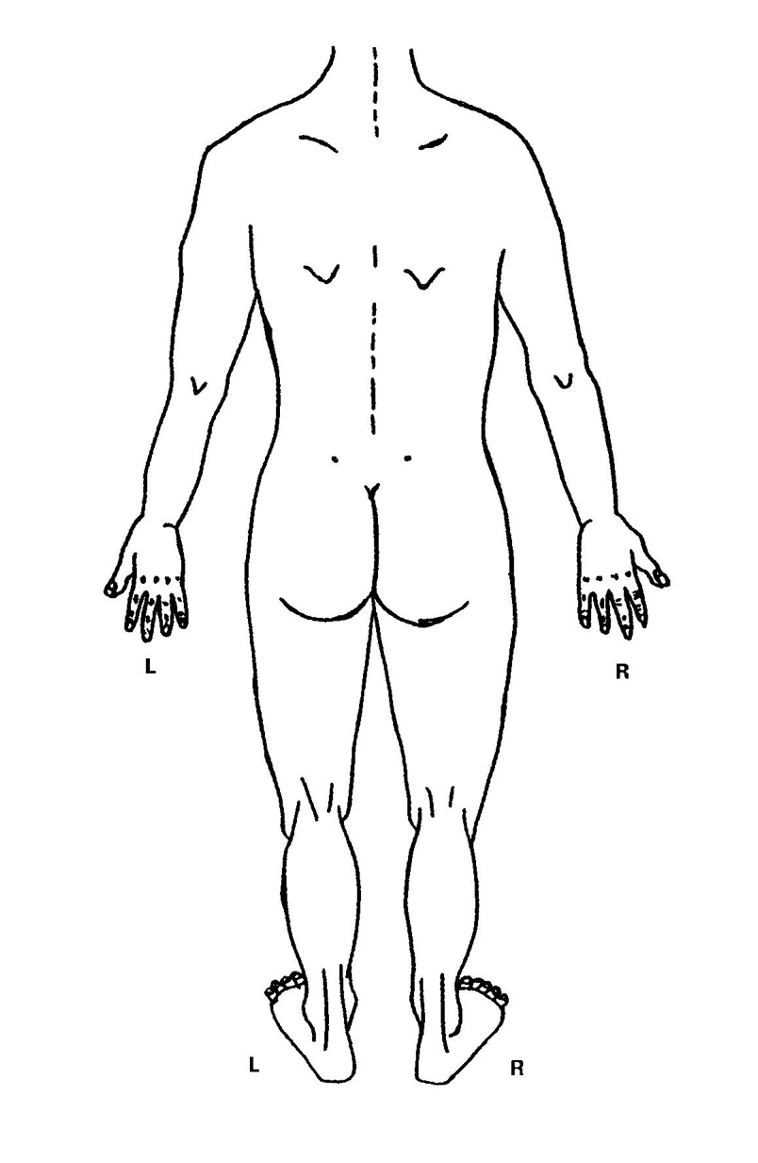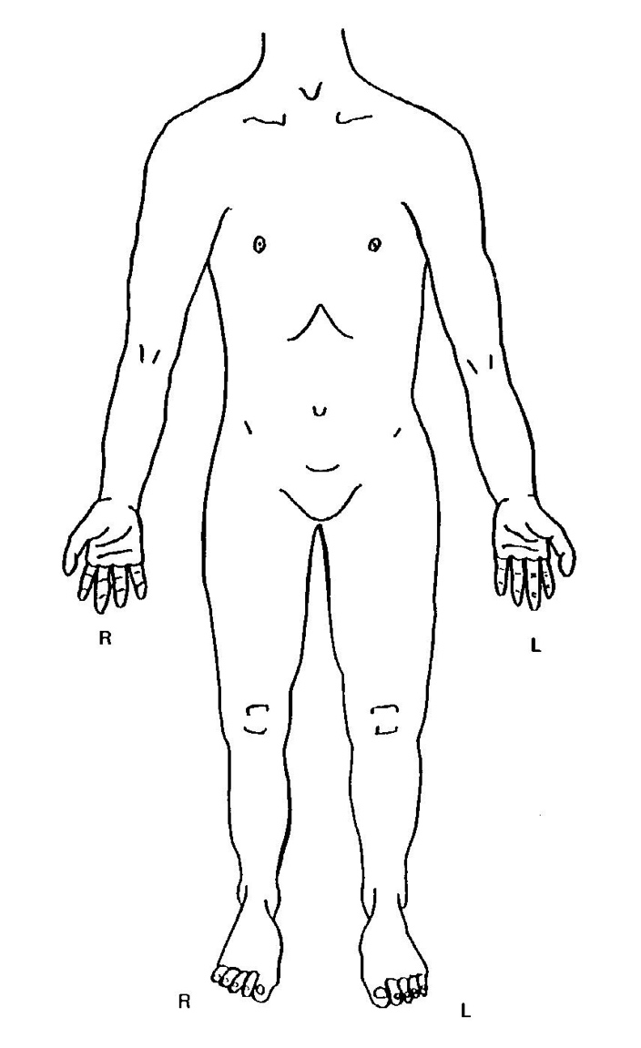

|  |  |
| --- | --- |
| **Name of child:** |  |
| **Date recorded:** |  |
| **Type of injury:** |  |
| **Position:** |  |
| **Shape:** |  |
| **Size:** |  |
| **Colour:** |  |
| **Observations:** |  |

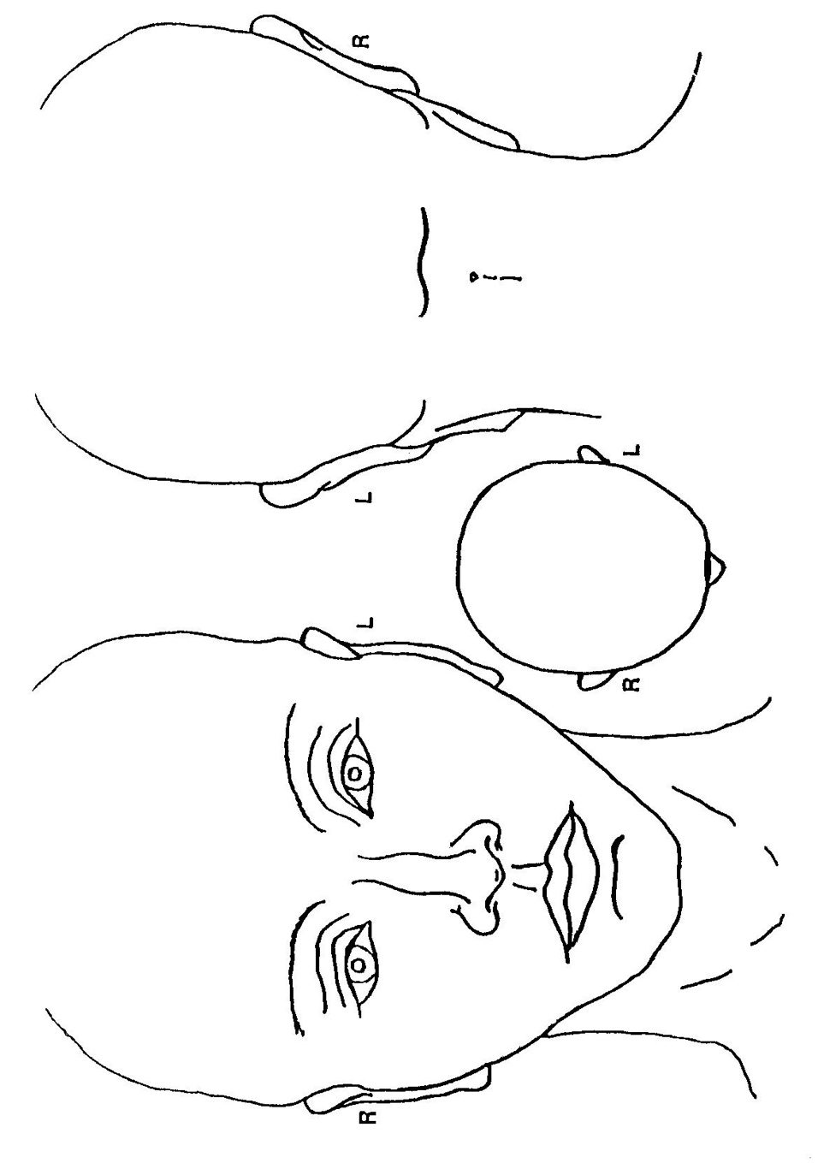

|  |  |
| --- | --- |
| **Name of child:** |  |
| **Date recorded:** |  |
| **Type of injury:** |  |
| **Position:** |  |
| **Shape:** |  |
| **Size:** |  |
| **Colour:** |  |
| **Observations:** |  |



**Appendix F**

**VALE OF GLAMORGAN LEARNING & SKILLS DIRECTORATE**

**YYD CHRONOLOGY LOG**

**Name:** **Date of Birth**:

**Class:**

|  |  |  |
| --- | --- | --- |
| **Date** | **Significant Event** | **Action Taken** |
|  |  |  |
|  |  |  |
|  |  |  |
|  |  |  |
|  |  |  |
|  |  |  |
|  |  |  |
|  |  |  |
|  |  |  |
|  |  |  |
|  |  |  |
|  |  |  |
|  |  |  |
|  |  |  |
|  |  |  |
|  |  |  |
|  |  |  |
|  |  |  |

**Appendix G Template Reports Conference**

|  |  |
| --- | --- |
| **Vale of Glamorgan Learning & Skills Directorate** | |
| **REPORT FOR CHILD PROTECTION CONFERENCES** | |
| **Pupil’s name:**  **Date of birth:**  **Address:**  **School:** | **Type of Conference: Initial/Review/Other**  **Author of report:**  **Year Group:**  **Date:** |
| **1. Information regarding incident or concerns that led to the MARF.** | |
| **2. Brief chronology of involvement or attach Chronology Log** | |
| **3a. Child’s development needs**  e.g. Educational progress, EP/BIT/EWO involvement, attendance, any EBD  concerns, relationship with family and peers, social presentation  **3b.** Known health concerns, involvement of school nurse | |
| **4. Comments on your observations of parenting**  e.g. Parents meeting basic care needs, ensuring safety and stability, providing guidance and boundaries, providing emotional warmth, promoting learning and intellectual development, working relationship with school. | |
| **5. Any other relevant information**  e.g. family history and functioning, housing, employment | |
| **6. The child’s/young person’s voice:** | |
| **7. Consideration of perceived risk:** | |
| **Has this report been shared with parents?**  **Yes/No** | |
| **Signed: Position in school:**  **Date:** | |

**Appendix H – MARAC Template**

Dorian Davies

01446 709867

07816 896572

[dpdavies@valeofglamorgan.gov.uk](mailto:dpdavies@valeofglamorgan.gov.uk)

**RESTRICTED AND CONFIDENTIAL INFORMATION**

Head teacher

Vale of Glamorgan

Dear Headteacher,

The pupil(s) listed below are due to be discussed at the forthcoming Domestic Abuse Multi-Agency Risk Assessment Conference (MARAC) for **high risk** cases on **date**.

|  |  |  |  |
| --- | --- | --- | --- |
| Pupil | DOB | SA/SA+/SEN | Address |
|  |  |  |  |
|  |  |  |  |
|  |  |  |  |

It is vital that the MARAC members receive as much information as possible to assist in targeting the necessary intervention for the family. Could you therefore, please provide comments below:-

**Attendance:**

**Personal Presentation:**

**Level of Achievement and brief comment on progress:**

**Any Involvement with other agencies:**

**Changes in Behaviour:**

**Areas of concern:**

**Perception of any risk:**

**Please send or e-mail to:**

Caroline Cleary

Public Protection Unit, Uned Gwarchod y Cyhoedd

Central (East) BCU – BCU y Canol (Dwyrain)

Serving Bridgend & the Vale, Yn gwasanaethu Pen-y-Bont a’r Fro

Cowbridge Police Station, Gorsaf Heddlu Y Bontfaen

Giatgorllewin, Cowbridge, CF71 7AR. Westgate, Y Bont-Faen

Email: central-bcu-domestic@south-wales.pnn.police.uk

**and**

Dorian Davies

Safeguarding Officer

School Improvement and Inclusion Service

Vale of Glamorgan Council

Email: [dpdavies@valeofglamorgan.gov.uk](mailto:dpdavies@valeofglamorgan.gov.uk)

**Appendix J**





**Safeguarding Pupil Information record**

|  |  |  |  |  |  |
| --- | --- | --- | --- | --- | --- |
| **Name** |  | **DOB** |  | **UPN Number** |  |
| **Address** |  | | | | |

|  |  |
| --- | --- |
| **Primary PR Holder:**  (Parent or Children’s CYPS) |  |
| **Parents’ Names:** |  |
| **Parents’ Address:** |  |
| **Parents’ contact number:** |  |
| **Carer’s name (if not residing with Parents)** |  |
| **Carer’s Address:** |  |
| **Carer’s contact number:** |  |

|  |  |  |  |  |  |
| --- | --- | --- | --- | --- | --- |
| **Child Protection (CP)** | | **Looked After Children (LAC)** | | **Child In Need (CIN)** | |
| **Date of CP Registration:** |  | **Date become LAC:** |  | **Date become CIN:** |  |
| **Child Protection**  **Register Category:** |  | **Legal Status (if LAC):** |  | **Date ceased CIN:** |  |
| **Date ceased CP Registration:** |  | **Date ceased to be LAC:** |  |  |  |

|  |  |  |  |
| --- | --- | --- | --- |
| **Social Worker** |  | **Contact Number** |  |
| **CYPSCYPS Team Manager** |  | **CYPSCYPS Area Team** |  |
| **Additional Notes / Emergency Information:**  (e.g. early alert files, files for children causing concern, restrictions on contact, hazards, allergies, medical information or special family arrangements | | | |

**Appendix K Monitoring Log**

**MONITORING RECORD**

This sheet should only be completed with agreement from DSP or DDSP.

This sheet must be handed to DSP or DDSP at the end of each week.

|  |  |
| --- | --- |
| **Pupil’s name:** |  |
| **Date of birth:** |  |
| **Class Teacher:** |  |
| **Social Worker:** |  |
| **Designated Senior Person:** |  |

|  |  |  |  |
| --- | --- | --- | --- |
| **Date** | **Concern** | **Action taken** | **Recorded by** |
|  |  |  |  |

**Appendix L**

## Suggested Safeguarding File Composition

The following guidance from Education Safeguarding is regarding the storage of information in School on vulnerable children and those involved with CYPSCYPS. Each child should have an individual file and all information should be in date order **with the most recent first,** in the following sections:

#### Safeguarding School File

1. Safeguarding Pupil Information record
2. Chronology of school concerns
3. Correspondence
4. Children’s CYPS Minutes – Conference/Core Group Minutes, LAC Review Meetings, Child in Need Planning Meetings
5. School reports for Children’s CYPS Meetings – i.e. Case Conference Meetings, LAC Reviews, Core Groups, MARAC
6. Attendance Data – Registration sheets, (SIMS as and when required)
7. EWO involvement as and when required.

**School Server Pupil Information**

* Academic Assessment Information – Key Stage Assessments, end of year testing
* School based additional information e.g. Involvement with Educational Psychology Service, Behaviour Support Service, Additional Learning Needs Service. Copies of Statement of Special Educational Needs, IEP, IBP, PEP, Physical Intervention
* School Report
* Any other information – copies of referrals to other agencies

When a child leaves your school this confidential information must be copied, securely transferred to the new school and signed for by the new Head Teacher or Designated Senior Person. The receiving school must be made aware of the existence of a Safeguarding file prior to the child transferring.

**Appendix M**

**Visitors and New Staff**

**Safeguarding**

**Information**

**September 2016**

**If you have any concerns you must immediately speak to either:**

|  |  |  |  |
| --- | --- | --- | --- |
| **../../../../Volumes/Shared/02%20-%20School%20Information/School%20colour%20photos%2** | **../../../../Volumes/Shared/02%20-%20School%20Information/School%20colour%20photos%202014:** | **../../../../Volumes/Shared/02%20-%20School%20Information/School%20colour%20photos%202014:** | **../../../Volumes/Shared/02%20-%20School%20Information/School%20colour%20photos%202014** |
| **Sian Davey**  **Assistant Headteacher** | **Josie McAllister**  **Acting Deputy Headteacher** | **Kerrie Pritchard**  **Assistant Headteacher** | **Claire Gould**  **Deputy Headteacher** |
|  | **../../../Volumes/Shared/02%20-%20School%20Information/School%20colour%20photos%202014:15/Ch** | **../../../Volumes/Shared/02%20-%20School%20Information/School%20colour%20photos%202** |  |
|  | **Christopher Britten (DSP)**  **Headteacher** | **Tim Exell**  **Chair of Governors** |  |

**Child Protection Policy**

**Model Note for Staff**

**What to do if a child tells you they have been abused by someone other than a**

**member of staff – September 2016**

*NB. Where the allegation is against a member of staff you should refer to Welsh Government Circular 002/2013:* ***Disciplinary and Dismissal Procedures for School Staff.***

A child may confide in any member of staff and may not always go to a member of the teaching staff. Staff to whom an allegation is made should remember:

* yours is a listening role, do not interrupt the child if he or she is freely recalling significant events. Limit any questions to clarifying your understanding of what the child is saying. Any questions should be framed in an open manner so as not to lead the child.
* you must report orally to the school’s designated senior person for child protection immediately.
* make a note of the discussion, as soon as it is reasonably practicable (but within 24 hours) to pass on to the school’s designated person for child protection. The note which should be clear in its use of terminology should record the time, date, place and people who were present and should record the child’s answers/responses in exactly the way they were said as far as possible. Remember, your note of the discussion may be used in any subsequent court proceedings.
* do not give undertakings of absolute confidentiality.
* that a child may be waiting for a case to go to the criminal court, may have to give evidence or may be awaiting care proceedings.
* your responsibility in terms of referring concerns ends at this point, but you may have a future role in terms of supporting or monitoring the child, contributing to an assessment or implementing child protection plans.

**Confidentiality**

Confidentiality issues need to be understood if a child divulges information they are being abused. A child may only feel confident to confide in a member of staff if they feel that the information will not be divulged to anyone else. However, education staff have a professional responsibility to share relevant information about the protection of children with the designated statutory agencies when a child is experiencing child welfare concerns.

It is important that each member of staff deals with this sensitivity and explains to the child that they must inform the appropriate people who can help the child, but that they will only tell those who need to know in order to be able to help. They should reassure the child and tell them that their situation will not become common knowledge within the school. Be aware that it may well have taken significant courage on their part to disclose the information and that they may also be experiencing conflicting emotions, involving feelings of guilt, embarrassment, disloyalty (if the abuser is someone close) and hurt.

Please remember that the pastoral responsibility of the education service. Ensure that only those with a professional involvement e.g. the designated senior person and the headteacher, have access to the child protection records. At all other times they should be kept securely locked and separate from the child’s main file.

The designated senior person for child protection in this school is:

**DSP: Chris Britten, Headteacher**

**Claire Gould, Deputy Headteacher**

**Josie McAllister, Acting Deputy Headteacher**

**Sian Davey, Assistant Headteacher**

**Kerrie Pritchard, Assistant Headteacher**

The designated Governor for child protection is:

**Tim Exell, Chair of Governors.**

**Ysgol y Deri Telephone number:** 02920 352292

The local authority designated lead officer for child protection is:

**Dorian Davies, Safeguarding Officer**

[**Dpdavies@valeofglamorgan.gov.uk**](mailto:Dpdavies@valeofglamorgan.gov.uk) Telephone: 01446 709867 07816 896572

**Appendix N**

**Ysgol y Deri Daily Contractor Log**

*CP info given to contractors should include name and location of DSP, and immediate actions required in reporting concern

|  |  |  |  |  |  |  |  |  |  |  |  |  |
| --- | --- | --- | --- | --- | --- | --- | --- | --- | --- | --- | --- | --- |
| **Date** | **Time**  **In** | **Time Out** | **Name** | **Company** | **Reason for Visit** | **CP info given\***  **(please tick)** | **Risk Assessment**  **of Contractor (must be completed)** | | | | | |
|  |  |  |  |  |  |  | Valid CRB |  | | Disclosure number |  | |
| Will be accompanied whilst on school site | | | | |  |
| Not in areas where lone pupils are | | | | |  |
|  |  |  |  |  |  |  | Valid CRB | |  | Disclosure number |  | |
| Will be accompanied whilst on school site | | | | |  |
| Not in areas where lone pupils are | | | | |  |
|  |  |  |  |  |  |  | Valid CRB | |  | Disclosure number |  | |
| Will be accompanied whilst on school site | | | | |  |
| Not in areas where lone pupils are | | | | |  |
|  |  |  |  |  |  |  | Valid CRB | |  | Disclosure number |  | |
| Will be accompanied whilst on school site | | | | |  |
| Not in areas where lone pupils are | | | | |  |
|  |  |  |  |  |  |  | Valid CRB | |  | Disclosure number |  | |
| Will be accompanied whilst on school site | | | | |  |
| Not in areas where lone pupils are | | | | |  |
|  |  |  |  |  |  |  | Valid CRB | |  | Disclosure number |  | |

**Appendix P**

**Social Services Duty Desks**

**Blaenau Gwent**

01495 315700

0800 3284432 **(Emergency Duty Team)**

**Bridgend**

01656 642320

0800 3284432 **(Emergency Duty Team)**

**Caerphilly**

0808 1001727

0800 3284432 **(Emergency Duty Team)**

**Cardiff**

02920 536490 (Children’s Access Point)

02920 536400 (Intake & Assessment for Pupils - Allocated Social Worker)

02920 788570 **(Emergency Duty Team)**

**Merthyr Tydfil**

01685 724506

01443 849944 **(Emergency Duty Team)**

**Monmouth**

0800 3284432 South East Wales **(Emergency Duty Team)**

01633 644054 Jane Rodgers, Safeguarding Manager

01633 644598 Jo Culleton, Child Protection Administrator

07917 707343 Maggie Teague, Lead Officer for Education

**Newport**

01633 656656 (Call Centre)

0800 3284432 **(Emergency Duty Team)**

**Swansea**

01792 635700

01792 775501 **(Emergency Duty Team)**

**Vale of Glamorgan**

01446 725202

02920 788570 **(Emergency Duty Team)**

01446 709843 David Davies, Child Protection Officer

01446 709147 Jane Werrett, ALN Support Manager