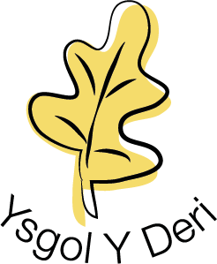

17th November 2020

COVID 19

Dear Parents/Guardians,

6 classes have been asked to self-isolate at home for a period of time due to positive test results for Covid-19 within their contact groups. If you have not had any direct contact from the senior leadership team at school in relation to this then your child is unaffected and can attend school as normal. These classes and cases are all in one geographical area of the school.

Ysgol y Deri’s information for parents about Covid-19 can be found on the school website. If you have any concerns you would like to discuss with school please get in touch. Please be assured that we have measures in place to keep YYD as safe as possible and we are fully compliant with all government and Public Health Wales guidance.

Kind regards
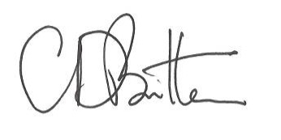

Chris Britten
Headteacher
Ysgol y Deri

Ysgol y Deri, Sully Road, Penarth, Vale of Glamorgan CF64 2TP
Tel 02920352280
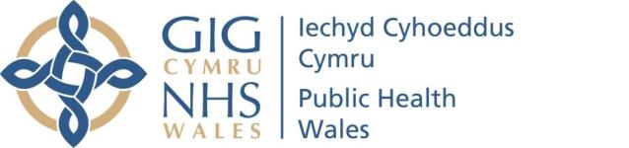
Schools and COVID-19 – Information for Parents
- Will my children be doing PE?
Yes, PE is really important for children, but lessons will be adapted to reduce risk of spread of COVID-19. You can make it much easier by checking when your child has PE lessons and making sure that they go to school in their PE kit on those days.
- Can children go to school with a cold?
If a child does not have symptoms of COVID-19 but has other cold-like symptoms, such as a runny nose, they do not need to be tested and they and you do not need to self-isolate. Your child can go to school if fit to do so.
- Are children able to go to school if a parent or another sibling, or anyone else in their house has symptoms of COVID-19?
If a child/parent/household member develops symptoms of COVID-19,
the entire household should immediately self-isolate, and book a test for the individual with the symptoms. It is not necessary to test the entire household if they are not symptomatic.
The COVID-19 symptoms are:
- • a new continuous cough
- • a high temperature
- • loss of or change to sense of smell or taste
4. Are children able to go to school if they have been in contact with someone who they don’t live with but who has symptoms of COVID-19?
If a child has been in “contact” with someone experiencing symptoms, they should carry on as normal until that individual receives their test result. If this is positive, the TTP Team will contact people identified as contacts.

14.09.2020 Version 1: Produced by Public Health Wales Page 1 of 3

Contact means:
- face-to-face contact with someone less than 1 metre away (including when you have worn a face covering or face mask)
- spending more than 15 minutes within 2 metres of someone
- travelling in a car with someone (even on a short journey)
6. What happens if the school has a positive case for COVID- 19?
When a confirmed case of COVID-19 is identified as attending an educational or childcare setting (staff or pupil) contact will be made with the case (or parent) to assess whether they attended the school during their infectious period and whether further tracing of contacts in the school is needed. If any staff member or child within the school is a contact of the case, they will be required to self-isolate for 14 days and contacted by your local Test, Trace, Protect (TTP) team or Education Department. If a staff member or child from the school is not a contact of the case, they will not be required to self-isolate.
7. Booking a COVID-19 test:
Only people with symptoms (a new continuous cough, a high temperature, or loss of or change in the sense of taste or smell) should be tested.
Pupils at Ysgol Y Deri can arrange a test through school rather than using the NHS portal. If you need to arrange a test during the day please contact your child’s class teacher. Outside of school hours (evenings 4.00-7.00pm and weekends) please e-mail your test request to Testing@yyd.org.uk. This e-mail address is monitored by members of the Senior Leadership Team. You will need to provide the following information:

- Childs full name
- Childs Date of birth
- Home Address
- Postcode
- Parents name
- Parents contact number (2 if possible)
- NHS number (if known)
- Do they have transport
- Description of symptoms

14.09.2020 Version 1: Produced by Public Health Wales Page 2 of 3

8. Self-isolation:
Anyone with COVID-19 symptoms, and anyone who lives with them, must self-isolate, even if symptoms are mild.
You must not go to school, nursery, other childcare settings, work, or places like a GP surgery, pharmacy or hospital.
Anyone with symptoms must self-isolate for 10 days from when their symptoms started. They can return to school or work after 10 days if they are well enough to do so.
Anyone in the household who does not have symptoms must self-isolate for 14 days from when the first person in the home started having symptoms.
A test is only needed for people who are symptomatic. People who are not symptomatic should not have a test.
Receiving a negative test result when you are a contact of a case does not shorten the isolation period, you will still be required to isolate for 14 days if you are a confirmed contact of a positive case.
If a parent thinks their child has symptoms BUT chooses not to put them through a test all household members must remain in self-isolation for 14 days from the onset of symptoms.
If you receive a positive test result, you will be contacted by the TTP Team.
If the person who has symptoms has a negative test, self-isolation can end for everyone, children may return to school and parents can return to work if they are well enough and as long as nobody else in the household has developed symptoms.

14.09.2020 Version 1: Produced by Public Health Wales Page 3 of 3

